Whiteness, Myth, and Masculinity: Spiritual Fragments from Charlottesville

By Eric Martin

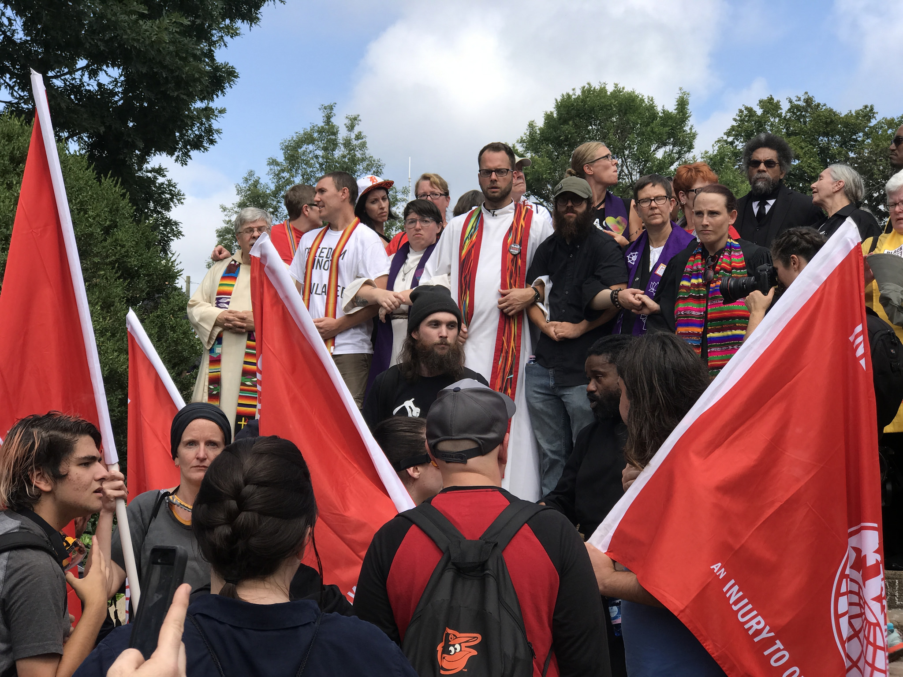

Photo Credit: Anthony Crider

https://www.flickr.com/photos/acrider

The voice of Malcolm X sounded from above, unmistakable in its anger. Thrown off balance, I looked up and saw two speakers atop a three-story building overlooking the chaos. The silhouette between them gazed down on me in my priestly stole and flashed me the peace sign as I walked by. I waved back as the voice became James Baldwin’s, and I wondered how many of the white supremacists on the streets recognized the sound of black resistance invisibly subverting their nationalism in real time. Their battle gear turned for a moment into what it was: makeshift wooden boards and goofy ski goggles. A closer look transformed a portion of soldiers into teens who appeared too young to grow facial hair. I was suddenly aware of how many pimples dotted the landscape of rage and the surprising amount of bodies that shuffled slightly, almost imperceptibly, away from the intense fighting.

But the escape was momentary. The blood was real, as was the harsh brutality and lust for violence on display only yards away. If there were scared boys in helmets, there were also men who looked capable and hopeful of killing.

It was fitting, for me, to be lifted away by the voice of Malcolm X on a day when masculine anger reared its toxic head. I recalled Adam, an old student of mine, who had entered a class I taught on Dr. King as a devout white supremacist and left in wild admiration of Malcolm X, whose speech on “The Ballot or the Bullet” convinced him that “being anti-racist can be manly too.” I have wondered since then about the lure of a certain stereotype of manliness, with power enough to convince someone that entire sets of humans are their enemies, and in some cases the *only* force powerful enough to overcome that conviction. That day in Charlottesville, I saw a crowd whose idea of “being a man” imagined nothing beyond war movies and middle school fictions. For all I know, Malcolm X may have saved Adam and I from meeting on separate sides that afternoon, but I question what can protect our society from this construct of masculinity that keeps dividing us into others in need of conquering.

Only moments before, a small band of interfaith clergy had been blocking the entrance to the park in which various neo-Nazi and white supremacist groups were gathering. The first company gored through with sticks and shields, some of which bore the symbol of a Christian cross. We rearranged ourselves so the most able would bear the brunt of the next group and hold the line.

It is hard to express the absurdity of waiting for some neo-Nazi to come and smash you in the face with his shield. Standing there unarmed was a taste of faith’s naked form, proclaiming without words that truth is manifested through vulnerability rather than dominance, through receiving blows rather than dealing them. Those previously trite words nestle in the core of your soul in such a situation. The theologian and Catholic Worker Jim Douglass once told me of discipleship, “You have to walk through the darkness, but then you’re free.” I held those words with me as we stood our ground, wondering if it wasn’t a fear of darkness – of flesh – that brought all these white people here to begin with. Days like this will recur until we walk deeply into the darkness of our history, the darkness of privilege inherited from systematic exploitation, death, and genocide. And there we were – Muslims, Jews, and Christians – holding on to each other and hoping for whatever freedom lay on the other side of things, knowing that we will never have it until the very people these supremacists came to terrorize do too.

It was ironic that amid the obscene slurs chanted at us – most of which fixated on the neo-Nazi’s pure fright of queer people – they found it worthwhile to yell, “Commie scum,” because as we stood there the Wobblies [Link to Clarify who the Wobblies are?] appeared like manna, offering to form a protective barrier in front of us. And when a large group of antifascists mobilized on the other side of them to form a blockade in the street, I noticed for the first time how many women, people of color, and queer folk had come out to defend their streets and had now placed their bodies before ours. I have no clue whether the white supremacists would have attacked clergy as viciously as they did the group they met first, but since so few showed up for nonviolent confrontation I will never find out.

We had planned to move away as a group if fighting broke out to escort the more vulnerable out of harm’s way, so when it did, we left our space and hoped to avoid the pepper spray grenades flying our way. As we moved, the Muslim woman I had come arm-in-arm with, surprised by the constant homophobia coming from the rally, expressed concern for the trans people in the crowd. I marveled at her complete lack of self-regard as the brawls spread, nearing us at an unpredictable pace in the notable absence of police. Hundreds of people had come here from across the nation demanding their own advancement by force, and this small woman arrived willing to imperil herself for others.

The utterly inane narrative that good Christians are threatened everywhere by crazed Muslims would be laughable if it weren’t justification for so much killing, torture, and imperialism. I couldn’t help but feel as we walked away that this woman held a key to a sort of second innocence that we as a nation desperately need but have never really wanted. It was a glimpse of what we could have become as a people and, despite the hatred on that street, what we still can become.

When we reached our destination, we entered for the first time a designated safe space for the clergy (and those who, like me, they had invited along). The day took on the strange and surreal transition from getting to know each other over warm food and free drinks to our work around town amid what were essentially small, roaming armies under seemingly no control. At the door stood an armed guard protecting us with a rifle, a paradox within our attempt to witness nonviolently.

Several times we were applauded as we walked down the street, and people shouted thanks from their windows as we passed by. This oddity seemed almost to mock the near-hopelessness pervading everything. All day long it seemed we were trying to stop some implacable beast from asserting its will. We were more often than not reacting, ministering to those who were affected, cleaning up after moral messes. But we did not stop it. How could we?

And beasts eventually devour. A woman sprinted up and yelled the unbelievable words: someone drove their car into a crowd; come quick. Several of us ran to the scene before police tape was up. Glass and bodies were everywhere. Young girls lay bleeding on the curb nearby. Media took pictures of the victims and families screamed at them to stop. Anger and confusion and panic encompassed it all.

This was the wreckage of the myth of masculinity and power. It is a particular brand of *Christian* masculinity and power that once animated the original Nazis and Confederates, and that day it left a woman dead in its wake. It is the same Christian violence the Lakota and other indigenous tribes continue to reject, that queer folks, people of color, women, and Muslims continue to resist. This street was its ugly, hellish portrait.

Earlier that morning, we’d sung “This Little Light of Mine” loudly enough to drown out the neo-Nazis’ shouts of “Heretics!” And there were little lights throughout the day. But they were surrounded by darkness, and the darkness was white. For every Adam who is converted by Malcolm X, there are young neo-Nazis in Charlottesville who cannot hear him on the speakers over their own fearful chants, who lash out when anything but whiteness approaches. I do not know what it means to be free after walking through the darkness of August 12 because I am still in it. Our future may rest on our ability to realize that we all are.

*Eric Martin is a doctoral candidate at Fordham University currently living in Charlottesville, Virginia.*